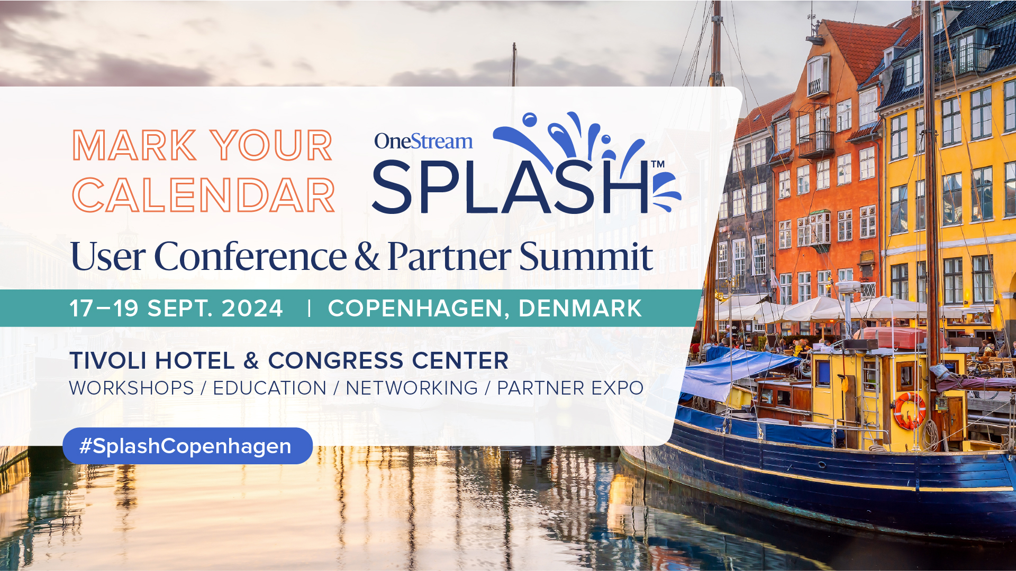

Request to attend OneStream Splash User Conference & Partner Summit in Copenhagen, Denmark

I am excited to request approval to attend OneStream Splash User Conference & Partner Summit, a three-day event taking place on 17-19 September 2024 in Copenhagen, Denmark at the Tivoli Hotel & Congress Center.
This annual conference by OneStream Software is an excellent opportunity to connect with finance and industry leaders from across the globe and to experience how to modernize finance with OneStream’s Intelligent Platform.
The conference offers 40 Breakout Sessions, two Keynote Sessions, Product Spotlights and hands-on Workshops, plus valuable insights from global companies, sharing their finance transformation success stories and best practices. By attending, I will learn firsthand about the latest solutions in the market and stay up to date with current industry trends.
In addition to insightful keynotes, real-world case studies, and a OneStream customer panel, the conference will also share some of the latest developments in AI Drive Finance and ESG reporting. As AI and machine learning (ML) increasingly play a role across enterprise planning processes, it is crucial for our team to learn more about solutions we can leverage in our planning to navigate the current and future market.
The conference fee is …… EUR to attend and three-days long, a highly cost-effective way to learn about the latest finance platform technologies and network with peers and industry leaders. Attending this event will provide invaluable long-term benefits for our ongoing finance roadmap and transformation plans.

Here’s an approximate breakdown of conference costs:

Conference Fee: | EUR XX
Hands-on Workshops Fee: | EUR XX
Airfare/Ground Transportation: | EUR XX
Accommodation: | EUR XX
Total: | £ XX

Thank you for considering my request to attend Splash Copenhagen.

